**Project Design Phase-II**

**Data Flow Diagram & User Stories**

|  |  |
| --- | --- |
| Date | 27 JUNE 2025 |
| Team ID | LTVIP2025TMID59804 |
| Project Name | Hematovision:Advanced Blood Cell Classification using Transfer Learning |
| Maximum Marks | 4 Marks |

**Data Flow Diagrams:**

A Data Flow Diagram (DFD) is a traditional visual representation of the information flows within a system. A neat and clear DFD can depict the right amount of the system requirement graphically. It shows how data enters and leaves the system, what changes the information, and where data is stored.

**Example:** [**(Simplified)**](https://developer.ibm.com/patterns/visualize-unstructured-text/)

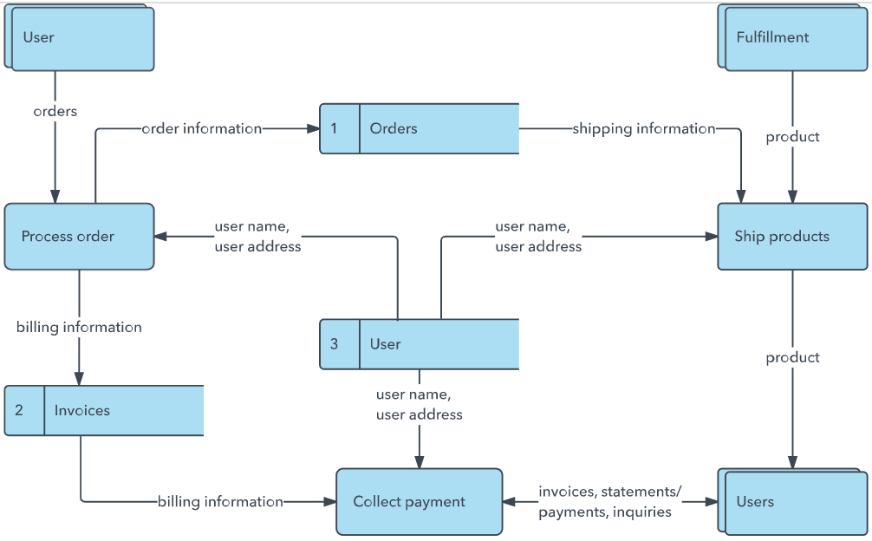

**Example** : DFD Level 0

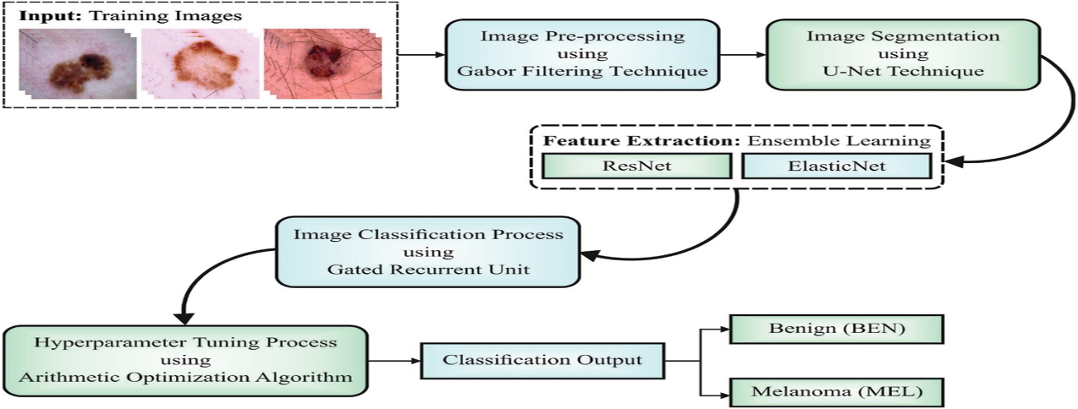

**User Stories**

| **User Type** | **User Role** | **User Story Number** | **User Story / Task** | **Acceptance Criteria** |
| --- | --- | --- | --- | --- |
| **Customer (Mobile user)** | **Medical Lab Tech** | **USN-1** | |  | | --- | | **As a medical lab technician, I want to upload blood smear images so that I can analyze them automatically.** |  |  | | --- | |  | | **Upload button available; Supports standard image formats (JPG, PNG); Shows upload confirmation.** |
|  | |  | | --- | | **ML Engineer** |  |  | | --- | |  | | **USN-2** | |  | | --- | | **As an ML engineer, I want to apply transfer learning models (e.g., ResNet, EfficientNet) so that training is efficient and accurate.** |  |  | | --- | |  | | **Pretrained model can be loaded; Custom layers can be fine-tuned; Logs accuracy and loss metrics.** |
|  | **Researcher** | **USN-3** | **As a researcher, I want to visualize the dataset distribution so that I can detect imbalance issues.** | **Bar chart of class distribution; Option to download summary stats (CSV).** |
|  | |  | | --- | | **Data Scientist** |  |  | | --- | |  | | **USN-4** | **As a data scientist, I want to evaluate model performance metrics so that I can assess its reliability.** | **Confusion matrix, accuracy, precision, recall, F1 score available post-evaluation.** |
|  | **User (General)** | **USN-5** | **As a lab administrator, I want the system to log predictions with timestamps so that we can audit reports.** | **UI loads without error; Contains clear options for upload, predict, view results.** |
|  | **Lab Admin** | **USN-6** | **As a lab administrator, I want the system to log predictions with timestamps so that we can audit reports.** | **Each prediction stored with date, time, image ID, and predicted class in a retrievable log.** |

|  |  |  |  |
| --- | --- | --- | --- |
|  |  |  |  |
|  |  |  |  |
|  |  |  |  |
|  |  |  |  |
|  |  |  |  |
|  |  |  |  |
|  |  |  |  |
|  |  |  |  |
|  |  |  |  |
|  |  |  |  |
|  |  |  |  |
|  |  |  |  |